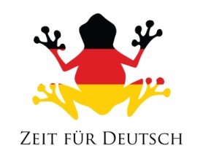
Sleep in heavenly peace | Holder Knabe | Alone watches | Heilige Nacht
Sleep in heavenly peace | Only the close, | Hochheilige Paar | Stille Nacht
Schlaf in himmlisher Ruh | Silent Night | Einsam wacht | Im lockigen Haar
Schlaf in himmlisher Ruh | All is sleeping | Most holy couple | Alles schläft
In curly hair | Holy Night | Blessed boy | Nur das Traute

Sleep in heavenly peace | Holder Knabe | Alone watches | Heilige Nacht
Sleep in heavenly peace | Only the close, | Hochheilige Paar | Stille Nacht
Schlaf in himmlisher Ruh | Silent Night | Einsam wacht | Im lockigen Haar
Schlaf in himmlisher Ruh | All is sleeping | Most holy couple | Alles schläft
In curly hair | Holy Night | Blessed boy | Nur das Traute

Sleep in heavenly peace | Holder Knabe | Alone watches | Heilige Nacht
Sleep in heavenly peace | Only the close, | Hochheilige Paar | Stille Nacht
Schlaf in himmlisher Ruh | Silent Night | Einsam wacht | Im lockigen Haar
Schlaf in himmlisher Ruh | All is sleeping | Most holy couple | Alles schläft
In curly hair | Holy Night | Blessed boy | Nur das Traute

