|  |  |
| --- | --- |
| die Maus | the mouse |
| das Insekt | the insect |
| das Zebra | the zebra |
| der Affe | the monkey |
| die Schildkröte | the turtle |
| die Eule | the owl |
| die Spinne | the spider |
| der Seehund | the seal |
| der Mensch | the human |
| das Eichhörnchen | the squirrel |

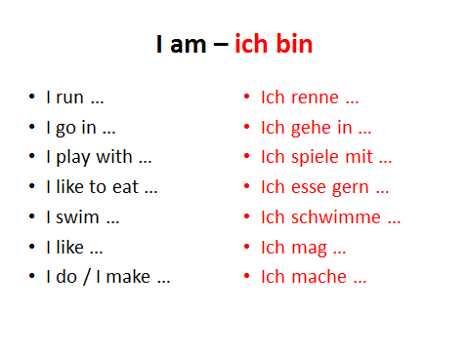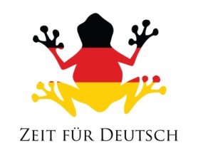 **New Animals**

