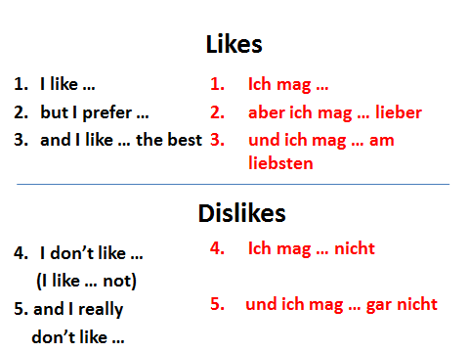

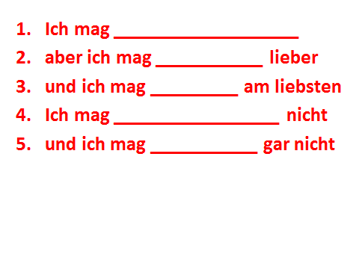
Clothes

Animals

Now make your own sentences about food, drink and school subjects
___________________________________________________________________________________________________________________________________________________________________________________________________________________________________________________________________________________________________________________________________________________________________________________________________________________________________________________________________________________________________

