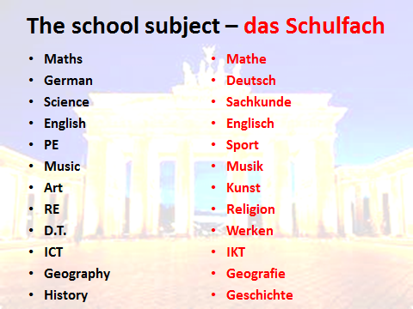

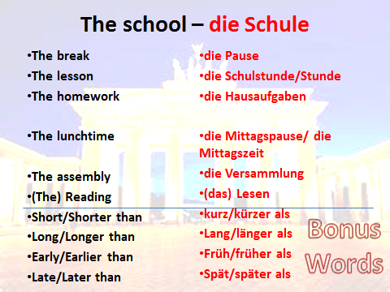

 | Montag | Dienstag | Mittwoch | Donnerstag | Freitag
1

2

3

4

5

6

7

8














