Translation 1 – Übersetzung 1
___________________________________________________
_________________________________________________________________________________________________________________________________________________________________________________________________________________________________________________________________________________________________________________________________________________________________________________________________________________________________________________________________________________________________________________________________________________________________________________________________________________________________________________________________________________________________________________________________________________________________________________
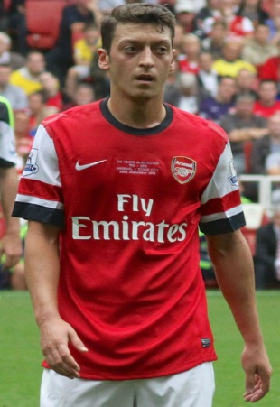
Translation 2 – Übersetzung 2
My name is Mesut Özil and I play football. I play for Arsenal in London and also for the German National Team. I am a Muslim and I speak German, English, Turkish and Spanish

_________________________________________________________________________________________________________________________________________________________________________________________________________________________________________________________________________________________________________________________________________________________________________________________________________________________________________________________________________________________________________________________________________________________________________________________________________________________________________________________________________________________
______________________________________________________________________________________________________________________________________________________________________________________________________________________________________________________________________________________________________________________________________________________________________________________________________________________________________________________________________________

