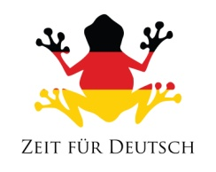
The Leg Das Bein
The knee Das Knie
The foot Der Fuß
The toe Der Zeh
The eyes Die Augen
The ears Die Ohren
The nose Die Nase
The mouth Der Mund
The chin Das Kinn
What is that? Was ist das?
That is ... Das ist ...

The body Der Körper
The head Der Kopf
The shoulder Die Schulter
The arm Der Arm
The elbow Der Ellbogen
The back Der Rücken
The stomach Der Bauch
The hand Die Hand
The finger Der Finger
The neck Der Hals

The body Der Körper
The head Der Kopf
The shoulder Die Schulter
The arm Der Arm
The elbow Der Ellbogen
The back Der Rücken
The stomach Der Bauch
The hand Die Hand
The finger Der Finger
The neck Der Hals

The Leg Das Bein
The knee Das Knie
The foot Der Fuß
The toe Der Zeh
The eyes Die Augen
The ears Die Ohren
The nose Die Nase
The mouth Der Mund
The chin Das Kinn
What is that? Was ist das?
That is ... Das ist ...

German Vocabulary Sheet – Body 1
www.zeitfuerdeutsch.com

