die Maus | the mouse
das Insekt | the insect
das Zebra | the zebra
der Affe | the monkey
die Schildkröte | the turtle
die Eule | the owl
die Spinne | the spider
der Seehund | the seal
der Mensch | the human
das Eichhörnchen | the squirrel
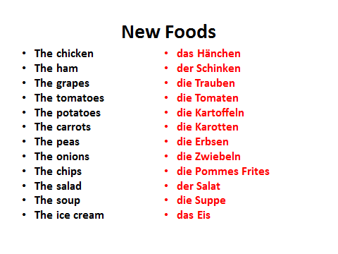
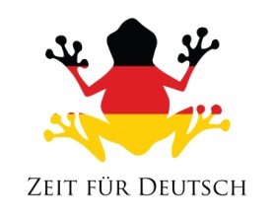
New Animals

5 things your German-English Dictionary tells you
1

2

3

4

5

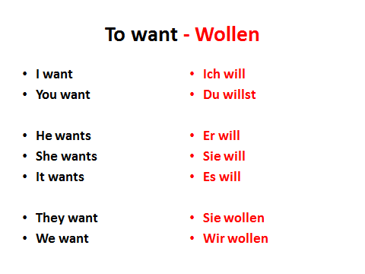
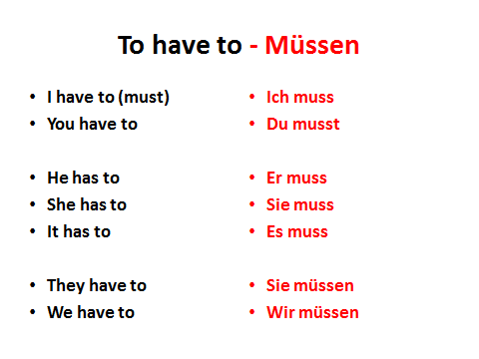
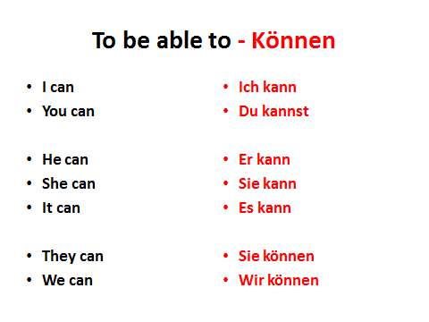

5 Adjective Challenge
German Adjective | English Translation | Sentence

Modal Verb Translation Challenge (Please use the dictionary)
1 | He wants to do it
2 | She can do it
3 | It has to do it
4 | They want to make it
5 | We can make it
6 | You (singular) have to make it
7 | They (plural) want to do it
8 | The owl can do it
9 | The squirrel can make it
10 | The monkey can make the salad

