****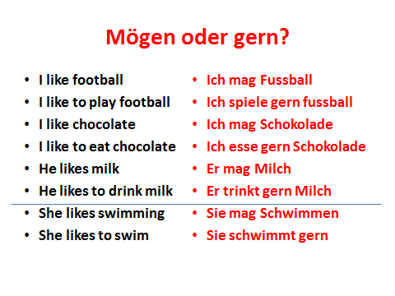

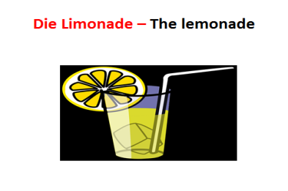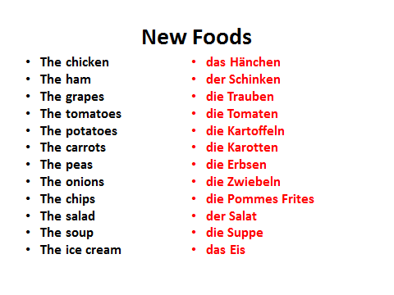

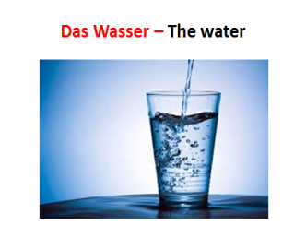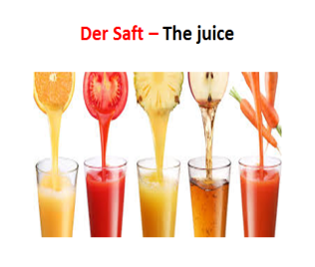

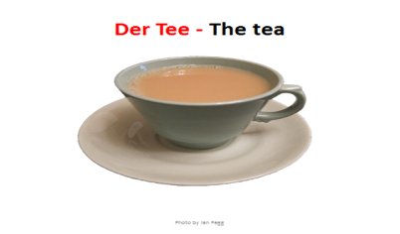

4 Sentences

________________________________________________________________________________________________________________________________________________________________________________________________________________________________________________________________________________________________________________________________________________________________________________________________________________________________________________________

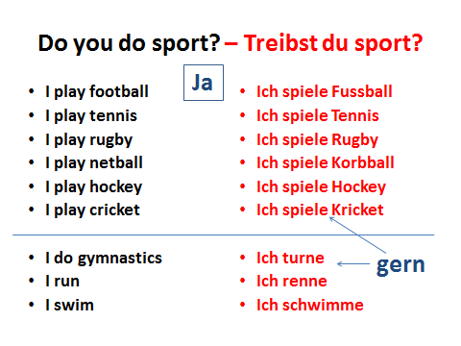

4 Sentences

