[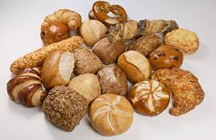](http://www.google.co.uk/url?sa=i&rct=j&q=&esrc=s&source=images&cd=&cad=rja&uact=8&ved=&url=http://www.baecker-mueller.de/backwaren-aus-dem-burgwald/broetchen.html&ei=Z6s8Vem-BsbSUZfSgeAB&bvm=bv.91665533,d.d24&psig=AFQjCNHDXMo0F9eU64RjtvrlmKwGXWb0SQ&ust=1430125799498240)[](http://www.google.co.uk/url?sa=i&rct=j&q=&esrc=s&source=images&cd=&cad=rja&uact=8&ved=&url=http://www.dailymail.co.uk/news/article-2349806/Fury-German-supermarkets-Sexist-sausages.html&ei=1Ks8VaDNBIv1UpPSgfAE&bvm=bv.91665533,d.d24&psig=AFQjCNEJB9sB3K0LJ3N_RNmcvNC2KrR9UQ&ust=1430125908386631)

[](http://www.google.co.uk/url?sa=i&rct=j&q=&esrc=s&source=images&cd=&cad=rja&uact=8&ved=0CAcQjRw&url=http://interactive.wxxi.org/highlights/2012/08/better-butter-marathon&ei=qKs8VaKMB4PpUvzygPAM&bvm=bv.91665533,d.d24&psig=AFQjCNGPVI2uY4mu0I3KIu1O-daf8jB4AA&ust=1430125852819364)[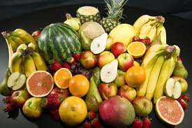](http://www.google.co.uk/url?sa=i&rct=j&q=&esrc=s&source=images&cd=&cad=rja&uact=8&ved=&url=http://en.wikipedia.org/wiki/File:Culinary_fruits_top_view.jpg&ei=16w8VavMCcnfaLmGgMgK&bvm=bv.91665533,d.d24&psig=AFQjCNGb-rJA3k-ftGc6RAvwm385EV1x2Q&ust=1430126167505998)[](http://www.google.co.uk/url?sa=i&rct=j&q=&esrc=s&source=images&cd=&cad=rja&uact=8&ved=&url=http://careers.theguardian.com/careers-blog/stay-positive-job-search&ei=a6w8Vb7VK8XrUoC1gYAF&bvm=bv.91665533,d.d24&psig=AFQjCNE0YkbfhqcLd2d6yThIiVV3aRN-dQ&ust=1430126060063352)[](http://www.google.co.uk/url?sa=i&rct=j&q=&esrc=s&source=images&cd=&cad=rja&uact=8&ved=&url=http://www.flo.hu/category/hirek/page/2&ei=96o8VYLeB4P9ULqtgKgO&bvm=bv.91665533,d.d24&psig=AFQjCNF_UKFxG5aZU_rsXRRGXIAdsrV0dQ&ust=1430125687499918)[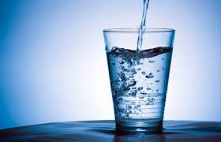](http://www.google.co.uk/url?sa=i&rct=j&q=&esrc=s&source=images&cd=&cad=rja&uact=8&ved=0CAcQjRw&url=http://imperfectlynatural.com/drink-healing-structured-water/&ei=V648VcHBDoLsat3agcAD&bvm=bv.91665533,d.d24&psig=AFQjCNEqWuNLSYnwWI54toRjPCBky0-dQg&ust=1430126536379829)[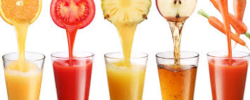](http://www.google.co.uk/url?sa=i&rct=j&q=&esrc=s&source=images&cd=&cad=rja&uact=8&ved=&url=http://www.wallpapermania.eu/wallpaper/good-morning-fresh-juice-summer-time&ei=xa08VZCEFILoaJmrgYAG&bvm=bv.91665533,d.d24&psig=AFQjCNHqJvbofVwYZuPwnGpp663nYxIJgA&ust=1430126405818958)[](http://www.google.co.uk/url?sa=i&rct=j&q=&esrc=s&source=images&cd=&cad=rja&uact=8&ved=0CAcQjRw&url=http://ethosorthodontics.com.au/blog/read/why-is-milk-good-for-my-teeth-when-it-is-high-in-sugar&ei=jK08VfijB8SUapbZgdgB&bvm=bv.91665533,d.d24&psig=AFQjCNEnyWY6LckjGyFq1wcfFdzL2Yf5lw&ust=1430126289702160)[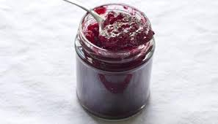](http://www.google.co.uk/url?sa=i&rct=j&q=&esrc=s&source=images&cd=&cad=rja&uact=8&ved=&url=http://www.bbc.co.uk/food/recipes/plum_glitter_jam_16796&ei=LKw8Vf-nIsL9UNCpgOAB&bvm=bv.91665533,d.d24&psig=AFQjCNEM0xkuZiiyD295Gb37gnfIPCwa1g&ust=1430125996784172)