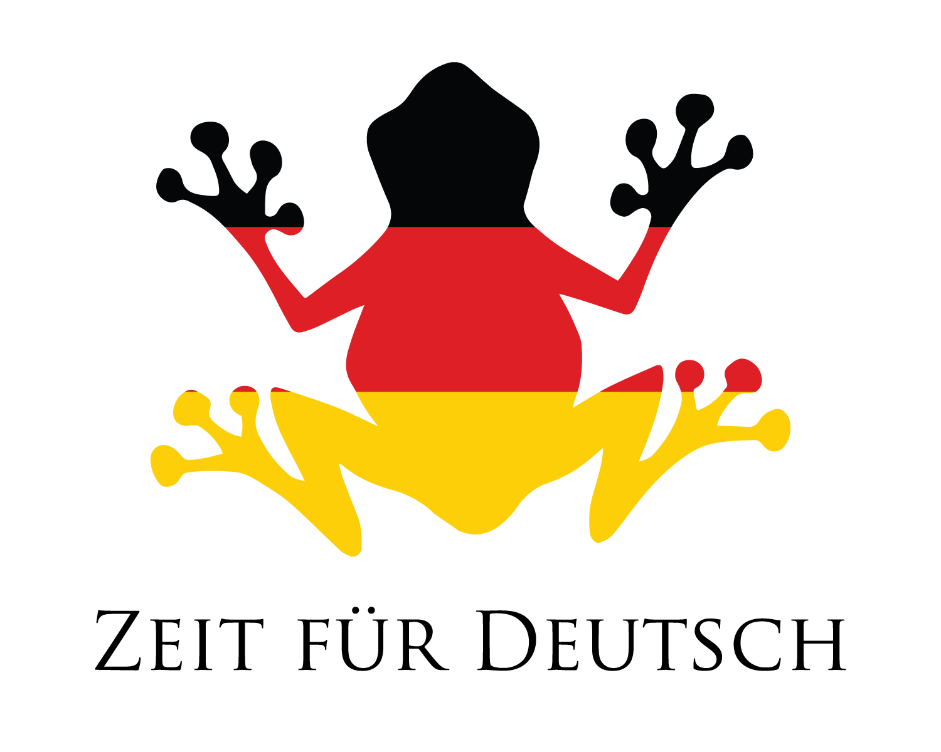

What is that? **Was ist das?**

Which colour has ..? **Welche Farbe hat ..?**

That is ... **Das ist ...**

Beautiful **Schön**

Or **Oder**

is **ist**

are **sind**

and **und**

The holiday **Der Urlaub**

I pack **Ich packe**

in my suitcase  **in meinen Koffer**

What is missing? **Was fehlt?**

The ... is missing **Die ... fehlt**

That was fantastic **Das war fantastisch**

No problem **Kein Problem**



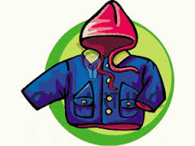**The clothes – Die Kleidung**

Gloves-Purple.ico

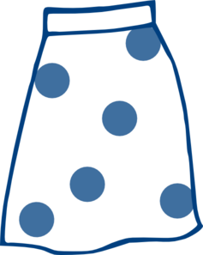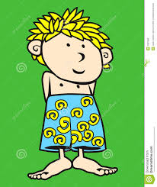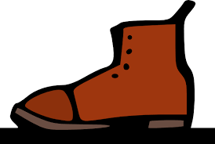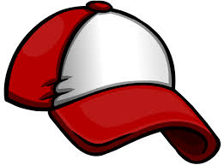

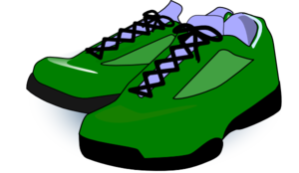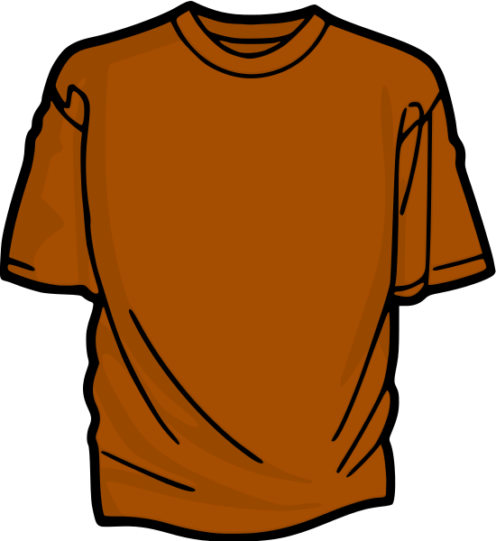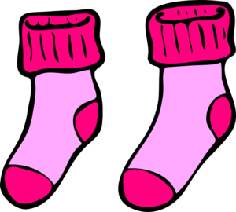

The skirt **Der Rock**

The coat **Der Mantel**

The boots **Die Stiefel**

The shorts **Die Shorts**

The blouse **Die Bluse**

The belt **Der Gürtel**

The jersey **Das Trikot**

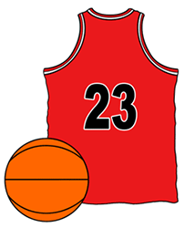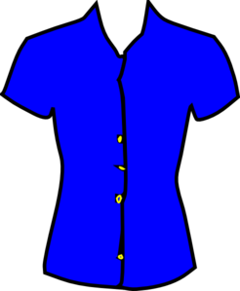

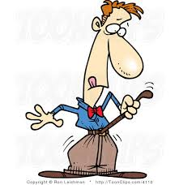

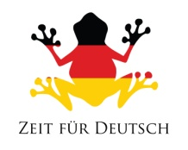

Last Week’s Handout



What is that? **Was ist das?**

Which colour is that? **Welche Farbe ist das?**

That is ... **Das ist ...**

Is that ...? **Ist das ...?**

Yes **Ja**

No **Nein**

is **ist**

are **sind**

and **und**

tremendous/super/ **prima**

great

**The clothes – Die Kleidung**

The trousers **Die Hose**

The jumper **Der Pullover**

The jacket **Die Jacke**

The scarf **Der Schal**

The dress **Das Kleid**

The hat **Der Hut**

The shoe **Der Schuh**

The shoes **Die Schuhe**

The sock **Die Socke**

The socks **Die Socken**

The T-Shirt **Das T-Shirt**

The glove **Der Handschuh**

The gloves **Die Handschuhe**

The shirt **Das Hemd**

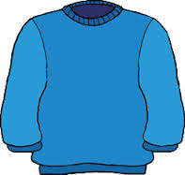Gloves-Purple.ico