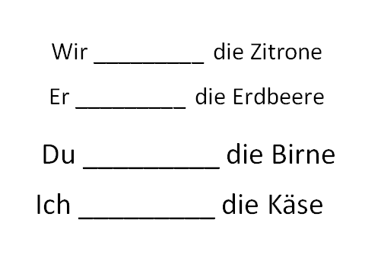
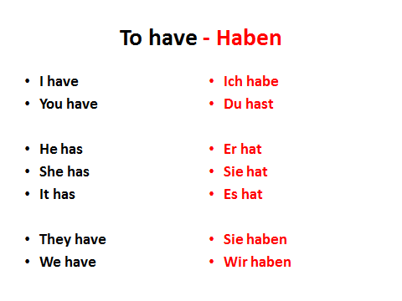
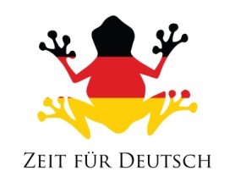

the shirt | das Hemd
the scarf | der Schal
the dress | das Kleid
the skirt | der Rock
the coat | der Mantel
the boot | die Stiefel
the blouse | die Bluse
the belt | der Gürtel
the jersey | das Trikot
the trousers | die Hose
the pear | die Birne
the pineapple | die Ananas
the lemon | die Zitrone
the cake | der Kuchen
the strawberry | die Erdbeere
the sausage | die Wurst
the fruit | das Obst
the juice | der Saft
the bread | das Brot
the cheese | der Käse
