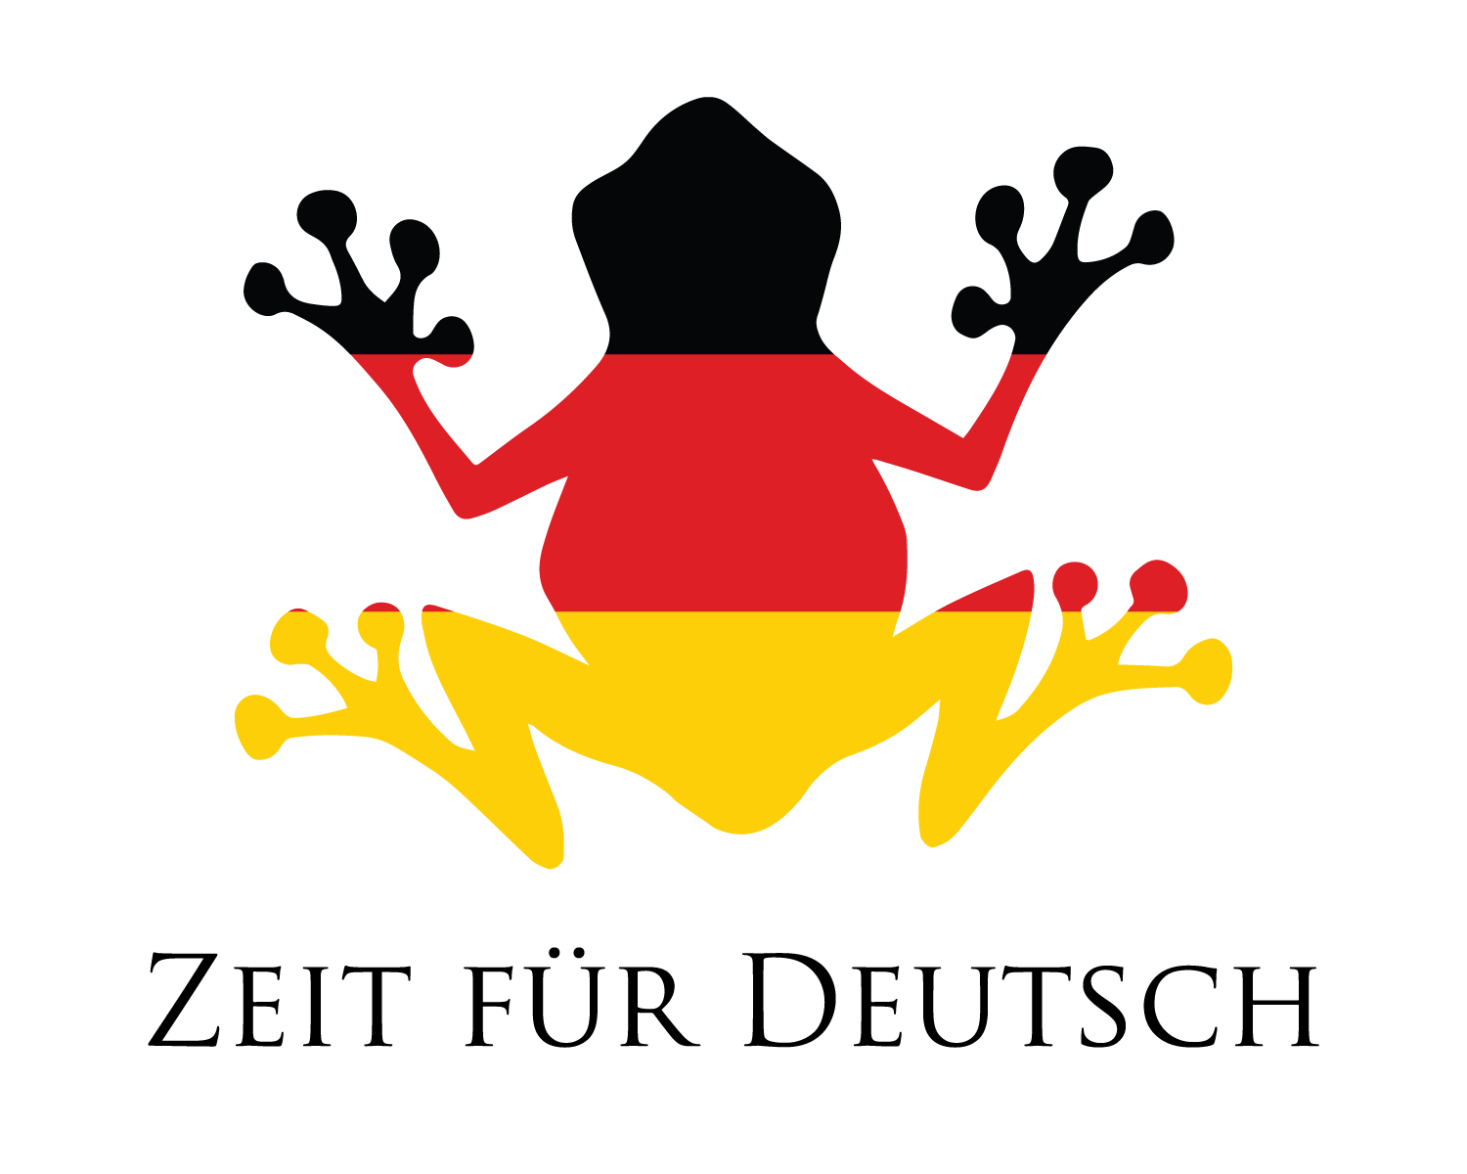

**Der Frosch – The frog Der Elefant The elephant**

**Die Ente – The duck Das Schaf The sheep**

**Die Kuh – The cow Bist du der/die/das ...?**

**Der Hund - The dog Are you the ...?**

**Die Katze – The cat Ja, ich bin der/die/das**

**Die Biene – The bee Yes, I am the ...**

**Das Krokodil - The crocodile Nein, ich bin nicht der/die/das**



**Das Pferd - The horse No, I am not the ...**

